

**BHARATI VIDYAPEETH’S**

**INSTITUTE OF COMPUTER APPLICATIONS & MANAGEMENT**

(Affiliated to Guru Gobind Singh Indraprastha University, Approved by AICTE, New Delhi)

COMPUTER NETWORKS (MCA-161)

Practical File

**Submitted To: Submitted By:**

**Mr. Manish Kumar Abhijeet Rana (01811604422)**

(Associate Professor) MCA 1st Sem, Section-1

INDEX

|  |  |  |  |  |
| --- | --- | --- | --- | --- |
| **Sr. No.** | **Experiments** | **Page No.** | **Date** | **Signature of Faculty** |
|  | Connecting 2 computers without a connecting Device. |  | 21.12.22 |  |
|  | Connecting 4 computers with a switch. |  | 21.12.22 |  |
|  | Connect 5 PCs through a Hub |  | 21.12.22 |  |
|  | Connect two network, one network using switch with 5 computers and another with 4 computer using hub |  | 22.12.22 |  |
|  | Connect two network using bridge |  | 22.12.22 |  |
|  | Demonstrate static routing by connecting 3 routers |  | 25.01.23 |  |
|  | Demonstrate dynamic routing using RIP protocol  by connecting 3 networks. |  | 25.01.23 |  |
|  |  |  |  |  |
|  |  |  |  |  |
|  |  |  |  |  |
|  |  |  |  |  |
|  |  |  |  |  |

# EXPERIMENT - 1

**AIM -** To connect 2 computers without a Connecting Device.

**THEORY -** A Copper cross-over cable is used to connect devices of same type and at same level in a network hierarchy.

Ex- Connecting PC to PC, Hub to Switch, Switch to Switch.

## PROCEDURE-

1. Open Packet Tracer and select two end devices(PCs) and place them on board.
2. Select Copper cross-over cable to connect first computer’s fast Ethernet Port to second computer’s fast Ethernet Port.
3. Configure IP Address of both PC with their Subnet Masks and make sure their Network Id is same.

Ex-

IP address of PC-0 = 192.168.2.1

Subnet Mask = 255.255.255.0

IP address of PC-1 = 192.168.2.2

Subnet Mask =255.255.255.0

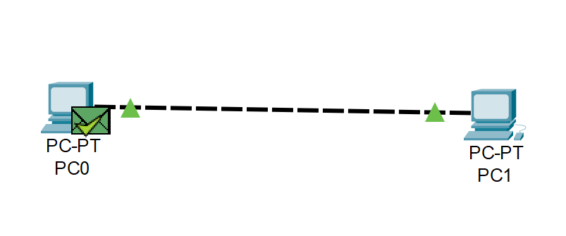

# EXPERIMENT - 2

**AIM -** Connect 4 computers with a Switch.

**THEORY -** A Straight-through cable is used when-

1. Connecting a router to a hub.
2. Connecting a computer to switch.
3. Connecting a LAN Port to a switch, hub, computer.

Switch is a computer networking device that links network segments or network devices. A switch is a device which receives a message from any device connected to it and then transmits the message only to the device for which the message was meant to send.

## PROCEDURE-

1. Open Packet Tracer and select four end devices(PCs) and a switch, and place them on board.
2. Select straight-through cable to connect first computer’s fast Ethernet Port to switch fast Ethernet Port. Follow same procedure to connect other 3 devices to switch.
3. Configure IP Address of PCs with their Subnet Masks and make sure their Network Id is same.

Ex-

IP address of PC-0 = 192.168.2.1

Subnet Mask = 255.255.255.0

IP address of PC-1 = 192.168.2.2

Subnet Mask = 255.255.255.0

IP address of PC-2 = 192.168.2.3

Subnet Mask = 255.255.255.0

IP address of PC-3 = 192.168.2.4

Subnet Mask = 255.255.255.0

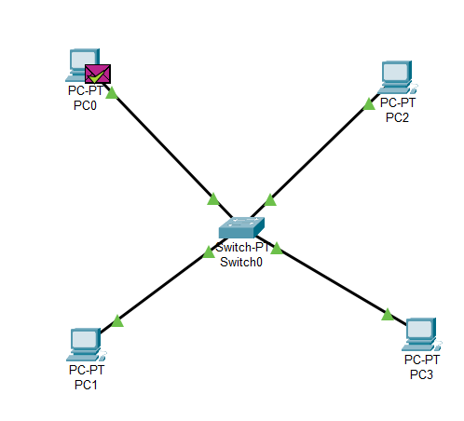

# EXPERIMENT - 3

**AIM -** Connect 5 PCs through a Hub

**THEORY -** A Straight-through cable is used when-

1. Connecting a router to a hub.
2. Connecting a computer to switch.
3. Connecting a LAN Port to a switch, hub, computer.

Hub is a Layer-2 networking device which transmits message to all PCs connected to it and also sends the corresponding acknowledgement of that message to all PCs.

Therefore, it is not considered as a smart networking device.

## PROCEDURE-

1. Open Packet Tracer and select five end devices (PCs) and a hub, and place them on board.
2. Select straight-through cable to connect first computer’s fast Ethernet Port to Hub fast Ethernet Port. Follow same procedure to connect other 3 devices to Hub.
3. Configure IP Address of PCs with their Subnet Masks and make sure their Network Id is same.

Ex-

IP address of PC-0 = 192.168.2.1

Subnet Mask = 255.255.255.0

IP address of PC-1 = 192.168.2.2

Subnet Mask = 255.255.255.0

IP address of PC-2 = 192.168.2.3

Subnet Mask = 255.255.255.0

IP address of PC-3 = 192.168.2.4

Subnet Mask = 255.255.255.0

IP address of PC-4 = 192.168.2.5

Subnet Mask = 255.255.255.0

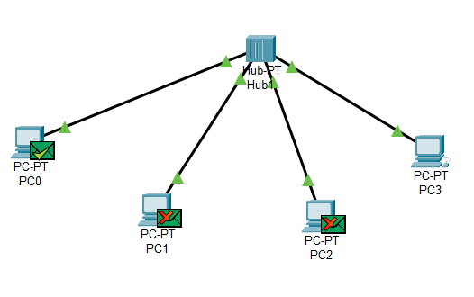

# EXPERIMENT – 4

**AIM -** Connect two network, one network using switch with 5 computers and another with 4 computer using hub

**THEORY-** A Copper cross-over cable is used to connect devices of same type and at same level in a network hierarchy.

Ex- Connecting PC to PC, Hub to Switch, Switch to Switch.

A Straight-through cable is used when-

1. Connecting a switch to a hub.
2. Connecting a computer to switch.
3. Connecting a LAN Port to a switch, hub, computer.

Hub is a Layer-2 networking device which transmits message to all PCs connected to it and also sends the corresponding acknowledgement of that message to all PCs.

Therefore, it is not considered as a smart networking device.

Switch is a computer networking device that links network segments or network devices. A switch is a device which receives a message from any device connected to it and then transmits the message only to the device for which the message was meant to send.

## PROCEDURE-

1. Open Packet Tracer and select 6 end devices (PCs), a hub, and a switch and place them on board.
2. For LAN-1 - Select straight-through cable to connect first computer’s fast Ethernet Port to hub fast Ethernet Port. Follow same procedure to connect other 2 devices to hub.
3. For LAN-2- Select straight-through cable to connect fourth computer’s fast Ethernet Port to switch fast Ethernet Port. Follow same procedure to connect other 2 devices to switch.
4. Connect hub and switch via Cross-wire cable by connecting hub fast Ethernet Port to switch fast Ethernet Port.
5. Configure IP Address of PCs with their Subnet Masks and make sure their Network Id is same.

Ex-

IP address of PC-0 = 192.168.2.1

Subnet Mask = 255.255.255.0

IP address of PC-1 = 192.168.2.2

Subnet Mask = 255.255.255.0

IP address of PC-2 = 192.168.2.3

Subnet Mask = 255.255.255.0

IP address of PC-3 = 192.168.2.4

Subnet Mask = 255.255.255.0

IP address of PC-4 = 192.168.2.5

Subnet Mask = 255.255.255.0

IP address of PC-5 = 192.168.2.6

Subnet Mask = 255.255.255.0

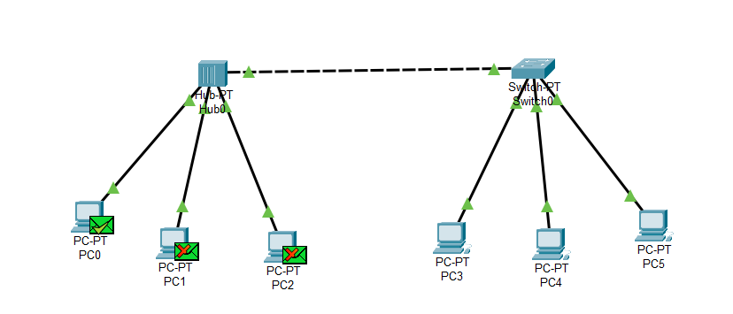

# EXPERIMENT – 5

**AIM -** Connect two network using bridge

**THEORY-** A bridge in a computer network is a device used to connect multiple LANs together with a larger Local Area Network (LAN). The mechanism of network aggregation is known as bridging. The bridge is a physical or hardware device but operates at the OSI model's data link layer and is also known as a layer of two switches.

A Straight-through cable is used when-

1. Connecting a switch to a hub.
2. Connecting a computer to switch.
3. Connecting a LAN Port to a switch, hub, computer.

**PROCEDURE-**

1. Open Packet Tracer and select 4 end devices (PCs), 2 switch and place them on board.
2. Select straight-through cable to connect first computer’s fast Ethernet Port to Switch1’s fast Ethernet Port. Follow same procedure to connect other PC to Switch1.
3. Select straight-through cable to connect third computer’s fast Ethernet Port to switch2’s fast Ethernet Port. Follow same procedure to connect other PC to switch.
4. Connect both switches to bridge via Cross-wire cable by connecting switch fast Ethernet Port to switch fast Ethernet Port.
5. Configure IP Address of PCs with their Subnet Masks and make sure their Network Id is same.

Ex- IP address of PC1= 192.168.1.1

Subnet Mask =255.0.0.0

IP address of PC2= 192.168.1.2

Subnet Mask =255.0.0.0

IP address of PC3= 192.168.1.3

Subnet Mask =255.0.0.0

IP address of PC4= 192.168.1.4

Subnet Mask =255.0.0.0

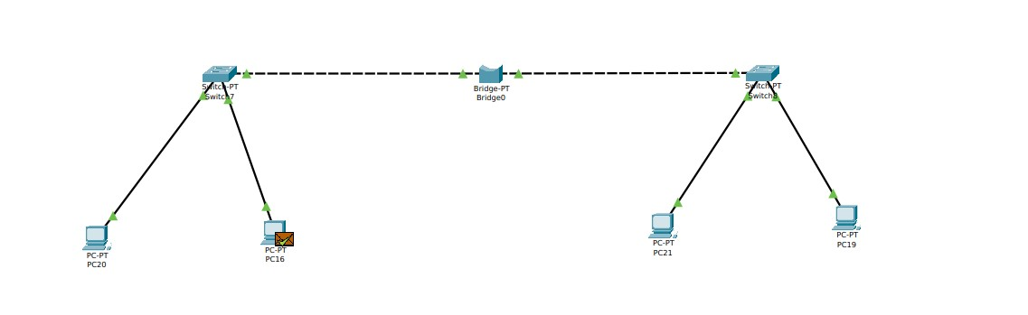

# EXPERIMENT – 6

**AIM -** Demonstrate static routing by connecting 3 routers.

**THEORY** A serial DCE wire is used to connect 2 routers within a

WAN (different cities). We need a serial Port to connect serial DCE wires to router.

A Straight-through cable is used when-

1. Connecting a switch to a hub.
2. Connecting a computer to switch.
3. Connecting a LAN Port to a switch, hub, computer.

**PROCEDURE-**

1. Open Packet Tracer and select 9 end devices (PCs), 3 Switches ,3 Router and place them on board.
2. Select Straight Through cable to connect PC0’s Fast Ethernet Port with switch 0’s Fast Ethernet Port. Similarly connect remaining PCs to their respective switch.
3. Configure IP addresses of different n/w IDs to LAN1(3PC and 1 Switch), LAN2(3PC and 1 Switch) and LAN3(3PC and 1 Switch).
4. Select Straight Through cable to connect switch0’s Fast Ethernet Port with router’s Gigabit Ethernet Port. Similarly connect other switch to router.
5. Add serial port to your router if it doesn’t have one.
   * + - Turn off Router.
       - Under Physical Section, Drag WIC-2T to your router. This will add 2 serial port to your router.
       - Turn on the router.
6. Configure LAN4 between Router 0 and Router 1.
7. Configure LAN5 between Router 1 and Router 2.
8. Connect router 0 with router 1 by connecting serial DCE cable to serial Port (0/0/0) of each router.
9. Connect router 1 with router 2 by connecting serial DCE cable to serial Port (0/0/1) of R2 with serial Port(0/0/0) of R3.
10. Give IP Address to Serial Port (0/0/0) of Router0 and Serial Port (0/0/0) of Router 1.
11. Give IP Address to Serial Port (0/0/1) of Router1 and Serial Port (0/0/0) of Router 2.
12. Give IP Address to each GigaBitInterface of each Router.
13. Give IP Address assigned to Router 0’s GigabitInterface0/0 to PC0, PC1, PC2 as Default Gateway. Similarly, Give IP Address of Router1’s GigabitInterface0/0 to PC3,PC4,PC5and Give IP Address of Router2’s GigabitInterface0/0 to PC6,PC7,PC8 as Default Gateway.
14. **Perform Routing, i.e, provide route to each of our router to identify diff n/w s under Config/Routing/Static.**

* Provide Route to R0-
  + 1. To identify LAN2 N/w:192.168.11.0 Mask:255.255.255.0 Next Hop:10.0.0.2
    2. To identify LAN3 N/w:192.168.12.0 Mask:255.255.255.0 Next Hop:10.0.0.2

* Provide Route to R1-
  1. To identify LAN1 N/w:192.168.10.0 Mask:255.255.255.0 Next Hop:10.0.0.1
  2. To identify LAN3 N/w:192.168.12.0 Mask:255.255.255.0 Next Hop:11.0.0.2

* Provide Route to R2-
  1. To identify LAN1 N/w:192.168.10.0 Mask:255.255.255.0 Next Hop:11.0.0.1
  2. To identify LAN2 N/w:192.168.11.0 Mask:255.255.255.0 Next Hop:11.0.0.1

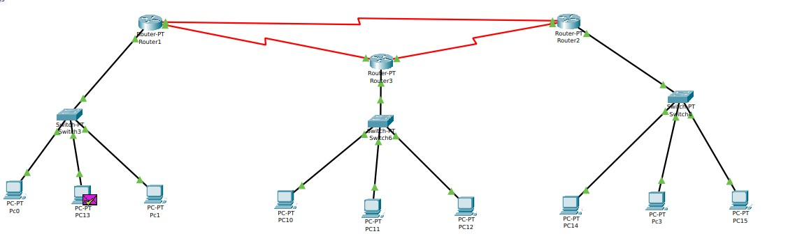

# EXPERIMENT – 7

**AIM -** Demonstrate dynamic routing using RIP protocol by connecting 3 networks.

**THEORY -** Routing Information Protocol (RIP) is a dynamic routing protocol which uses hop count as

a routing metric to find the best path between the source and the destination network.

**PROCEDURE-**

1. Open Packet Tracer and select 6 end devices (PCs), 3 Switches ,3 Router and place them on board.
2. Select Straight Through cable to connect PC0’s Fast Ethernet Port with switch 0’s Fast Ethernet Port. Similarly connect remaining PCs to their respective switch.
3. Configure IP addresses of different n/w IDs to LAN1(2PC and 1 Switch), LAN2(2PC and 1 Switch) and LAN3(2PC and 1 Switch).
4. Select Straight Through cable to connect switch0’s Fast Ethernet Port with router’s Gigabit Ethernet Port. Similarly connect other switch to routers.
5. Add serial port to your router if it doesn’t have one.
   * + - Turn off Router.
       - Under Physical Section, Drag WIC-2T to your router. This will add 2 serial port to your router.
       - Turn on the router.
6. Configure LAN5 between Router 0 and Router 1(10.0.0.0).
7. Configure LAN6 between Router 1 and Router 2(11.0.0.0).
8. Configure LAN7 between Router 0 and Router 2 (12.0.0.0).
9. Connect router 0 with router 1 by connecting serial DCE cable to serial Port(0/0/0) of each router.
10. Connect router 1 with router 2 by connecting serial DCE cable to serial Port (0/0/1) of R1 with serial Port(0/0/0) of R2.
11. Give IP Address to Serial Port (0/0/0) of Router0 and Serial Port (0/0/0) of Router 1.
12. Give IP Address to Serial Port (0/0/1) of Router1 and Serial Port (0/0/0) of Router 2.
13. Give IP Address to Serial Port(0/0/1) of Router0 and Serial Port(0/0/1) of Router 2.
14. Give IP Address to each GigaBitInterface of each Router.
15. Give IP Address assigned to Router 0’s GigabitInterface0/0 to PC0, PC1, as Default Gateway. Similarly, Give Default Gateway to PCs of LAN2, LAN3.
16. **Now provide every router with network ids of all LANs (including the n/w with which the router is directly connected) under Config / RIP section of router.**



* Here we have sent packet from PC13 to PC11.
* The observation to note is the packet is sent via LAN6(12.0.0.0) , i.e, packet is sent via the shortest possible path from Router0 to Router1.
* If this packet was sent via static path then it would’ve taken the route which was provided first